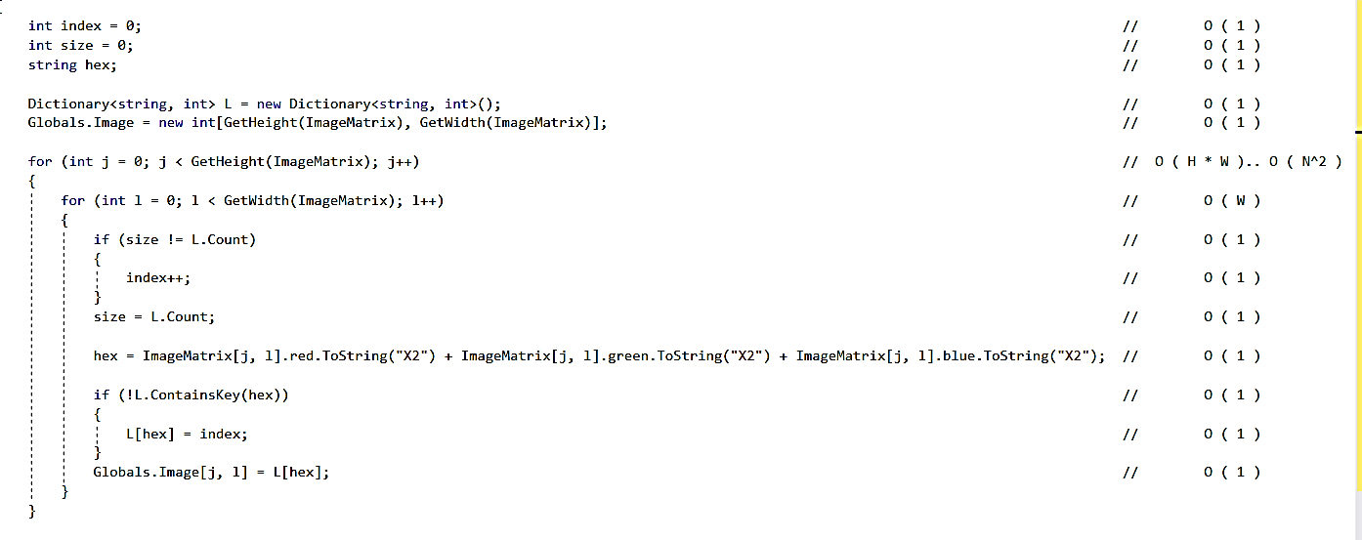Fill Graph Function. **O(H*W) . . . (N^2).**

A Dictionary is created with a Space of O(D) storing the Distinct Colors. Where each key is the hexacode (string) of the color given and the value is an index we assigned it to. A 2D Matrix of indices is created for printing the image in the last function (L*W).

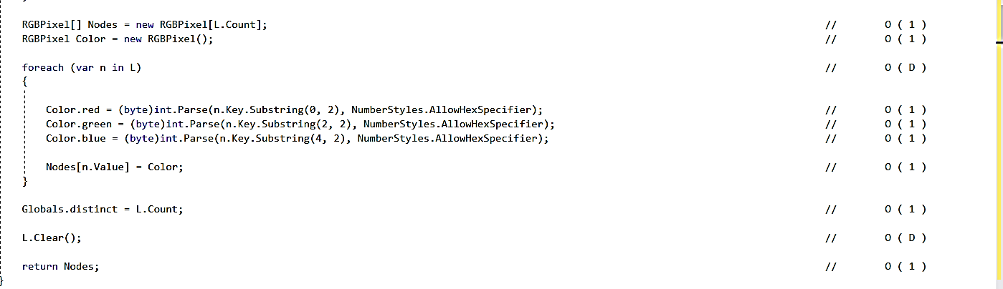

An Array of RGB is created to replace the Dictionary used earlier of Size O(D). Then the Dictionary is Cleared.

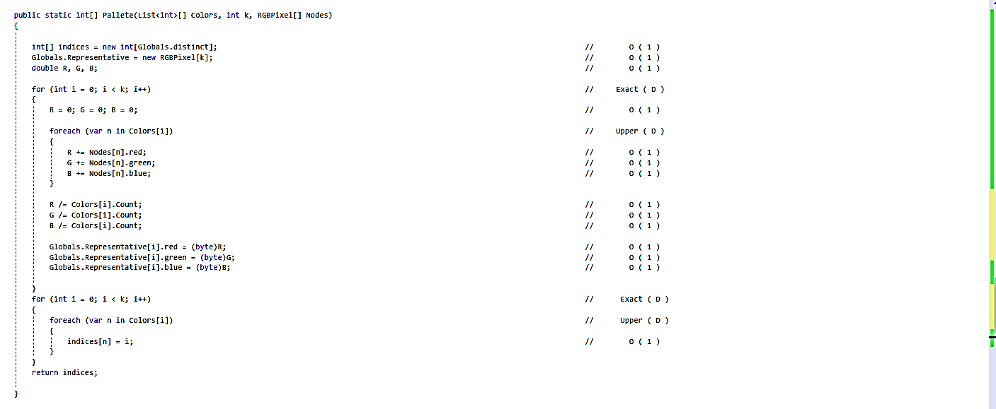Color Palette Function. **O(D)**

Array of indices is made with a space of **O(D)**. The Nested loop iterates over all Distinct Colors divided in Clusters. To calculate the Color Palette in a time Complexity of Exact **O(D)**.

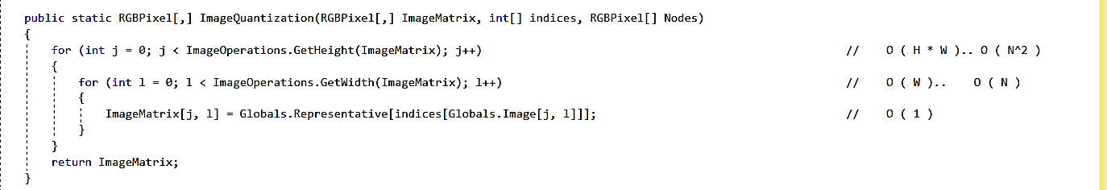

Image Quantization Function. **O(H*W) . . . (N^2).**

Colors in ImageMatrix are Replaced by the Representative Colors located in the Representative Array.

Clustering Function. **O(K*D)**

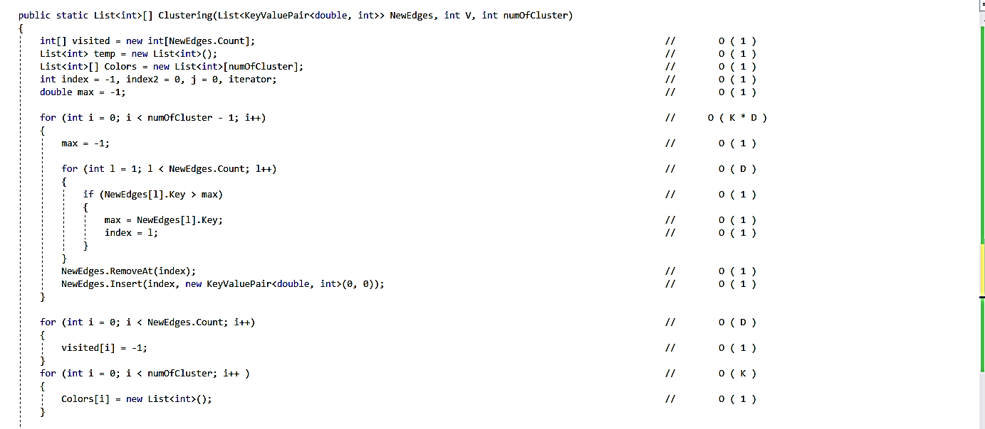

The Nested loop has a Time Complexity of O(K*D). Largest edges are found and removed according to the number of K. An Adjacency List of Clusters and a 1D array of indices (visited) is made and initialized with space **O(D)** for both.

Clustering Function. **O(K*D)**

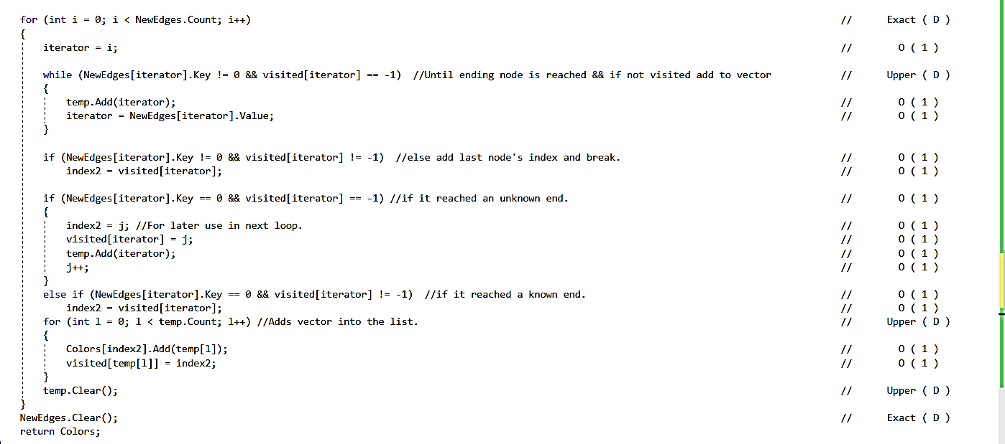

The Nested loop iterates over all Edges and marks them as visited in the process to avoid iterating on them again with a complexity of **O(D)**. Where the while loop iterates on the neighbors of Color and stores them in a temporary list until the Stopping condition is reached (No Connected Edge OR a visited Edge). Then the Colors stored are saved in the Adjacency list.